
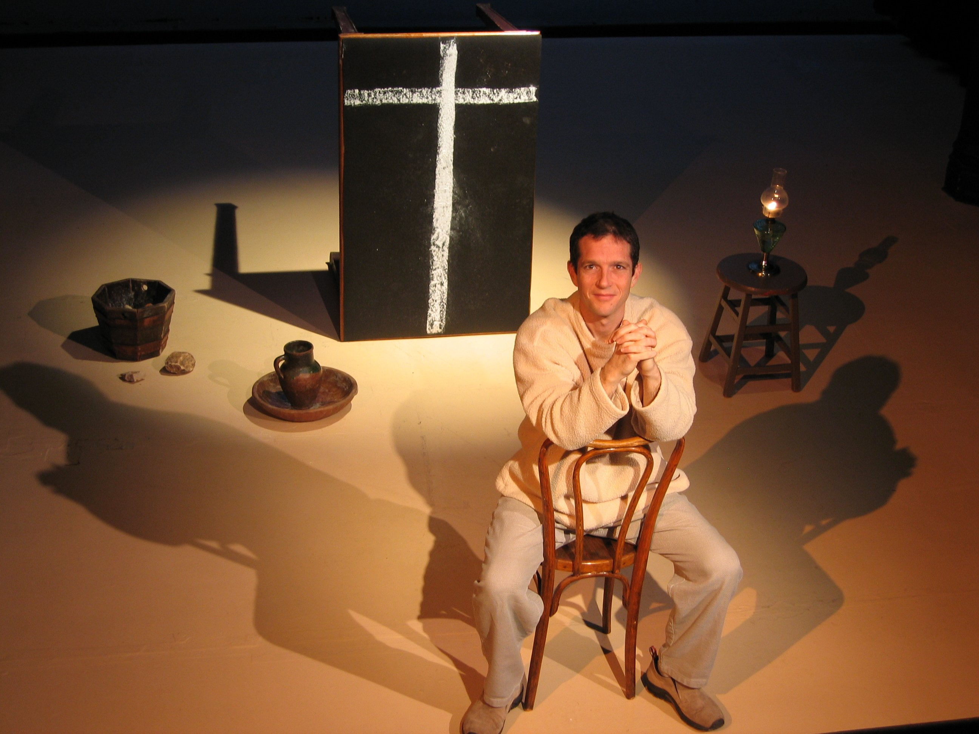
“a famously compelling tale, lively and engaging. Mr. Sherrill is a poised performer with a subtle physical grace”
----The New York Times

“an amazing achievement! A transforming two hours of theater….riveting!”
----Atlanta Journal-Constitution

“the Good Book gets even better … brings the New Testament to life.”
----The Washington Post

UPCOMING LIVE PERFORMANCE:
Location:
Address:
DATE: TIME:

