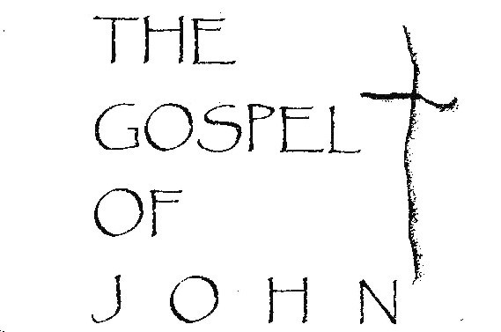

THE LIVE PERFORMANCE

Developed and Performed by BRAD SHERRILL

Program & Tour Manager MARK HICKMAN
Staged by SCOTT McTYER COWART

2

Act I: Chapters 1 – 11 (about 1 hour, 20 minutes)

Intermission (10-15 minutes)

Act II: Chapters 12 – 21 (about 50 minutes)

Translation: New International Version.

BRAD SHERRILL has been a professional actor for over 30 years. In 2001, he launched his series of groundbreaking one-man theatrical performances starting with The Gospel of John, which the Atlanta Journal Constitution immediately heralded as "amazing" and "riveting." Following successful theatrical runs off-Broadway, in Washington D.C., Chicago, Atlanta and Toronto, Brad celebrated his 600th live performance of The Gospel of John in 2012. He has now completed over 800 of his one-man performances worldwide, including shows in 40 states, the U.K., Canada and Ireland. Brad has premiered other new one-man works in recent years including Prophets (at Georgia Shakespeare, Atlanta 2010), Red Letter Jesus (at Theatre in the Square, Atlanta 2012 and Provision Theater Co., Chicago 2013) and Exodus (in November, 2013.) Brad most recently premiered Apostle, based on Acts and inspiring portions of Paul's letters. He now presents all performances in venues nationwide.
Through the years, Brad has been selected by both Atlanta Magazine and Creative Loafing (another Atlanta publication) as Atlanta's Best Actor. He has performed in over 20 productions at Atlanta's Alliance Theatre (the lead producing theatre in the Southeast) and has been an Artistic Associate for Georgia Shakespeare Co., where he has acted in 50 productions over 24 seasons.

MARK HICKMAN (Production & Tour Manager, Multimedia & Sound Designer) Mark has served as Brad’s tour manager since 2003 and is the program director at each performance. He captured the videography for Brad’s productions of Red Letter Jesus, Exodus and Apostle during 2011 through 2015 in Israel, Jordan, Egypt, the Sinai, Greece and Turkey. He created the multimedia design as well for all three performances. Mark also oversees promotion, maintains the performance website and creates the ongoing tour schedule. Mark has cherished his work over many years with Global Volunteers and Habitat for Humanity. Please visit www.globalvolunteers.org and www.habitat.org for a life-changing experience!

3

SCOTT McTYER COWART (Stage Direction) Scott graduated from Emory University in 1998. He originally staged The Gospel of John for its performances off-Broadway in 2003 and its numerous theater runs in Washington D.C. and Atlanta during 2001-2002. As an actor, he appeared on Broadway in The Rainmaker (with actor Woody Harrelson) and has appeared over the years in numerous Atlanta productions at the Alliance Theatre, the Georgia Shakespeare Festival and Theatre in the Square. Scott also designed The Gospel of John website at www.gospelofjohn.com.
THE GOSPEL OF JOHN - LIVE PERFORMANCE
It took Atlanta-based actor Brad Sherrill four months to commit the entire gospel (from the N.I.V. translation) to memory. Since its premiere in 2000, The Gospel of John has been performed over 600 times in churches, cathedrals, universities and professional theaters across the U.S., Canada, the U.K. and Ireland (including a six-week theatrical run off-Broadway at New York City’s historic Lamb’s Theatre) and at other professional theaters in Chicago, Washington D.C., Toronto and Atlanta. The Gospel of John's European cathedral tours in 2007, 2008 & 2009 brought the performance to large, historic cathedrals of the U.K., Ireland and Northern Ireland including Westminster Cathedral (London), Lincoln, Gloucester and Lichfield Cathedrals (U.K.), Christ Church Cathedral (Dublin) and St. Peter's Cathedral (Belfast.) Other performances have included the U.S. Naval Academy (Annapolis) and numerous colleges such as Yale, American and Catholic Universities. Brad’s live performances have now touched the hearts of over 250,000 people worldwide!
The performance website at www.gospelofjohn.com includes complete articles and reviews from The Washington Post, The Atlanta Journal Constitution, The New York Times and The Chicago Tribune in addition to hundreds of comments from pastors, theater attendees and church members. The latest performance schedule and booking information can also be accessed through the website.

4

A Personal Note from Brad:
WHY JOHN’S GOSPEL?

Since memorizing the almost 20,000 words which comprise the fourth Gospel, this has been the one question most frequently asked of me. I can only respond as other believers have by stating that John’s Gospel is nourishment for the mind, heart and soul. In John, Christ communicates with a directness, passion and authority which speaks not only to the body of humankind but to each of us as individuals.

My mission first and foremost in presenting John is to deepen my personal relationship with God through Christ. Secondly, by drawing upon my own faith in the Word and by utilizing the gifts God has given me in my work as a professional actor, I hope to bring John’s entire Gospel to vivid life in performance. I believe hearing the Gospel in this unique way will have the power to enrich your faith as it has mine. Thank you for joining me during these few hours.

Please share your response to the
performance by visiting us at:
www.gospelofjohn.com

The Gospel of John is taken from THE HOLY BIBLE, NEW INTERNATIONAL VERSION®, Copyright © 1973, 1978, 1984 by International Bible Society
Used by permission. All rights reserved worldwide.

